Firespitter parts guide

Download Firespitter from curseforge or pre-releases from github
or download the legacy version for KSP 0.19.1, v4.2
or legacy 0.22 version

Forum thread
Module cfg file documentation
Oblong base parts for model makers (blend and fbx)

Index

General information
Installation
Right click Events, Action groups and key bindings
Editing action groups
Tweakables and Action Group editor popups
Helicopter balance
Editing config files
Creating an alternate part
Scaling the part
Editing modules
Adding FS modules to stock parts
Parts
Wings
Wings with special lift code (biplane/F-86)
Testing
Axis response
Tweaks
Flaps
Leading Edge Slats
Landing Gears
Placement
Right click events / actions
Propellers
Pushing or pulling propellers
Fuel
Helicopter main rotors
Placement
Right click events / actions
The electric helicopter propeller
Tail rotors
VTOL
Placement
Right click events / actions
VTOL steering modes
Cockpits
Apache cockpit monitors
Texture switching and customizable nose art
Air brakes
Seaplane floats
Placement
Gyroscope (Avionics) / ASAS
Craft Info Popup
Bomb Bay
Trim adjustment tool
Buttons
Presets
Tips
Water Launch System

General information

Installation

Unzip the contents of the zip file directly to the KSP GameData folder, so the Firespitter folder ends up in the GameData catalog. For example: c:\games\KSP_win\GameData\Firespitter.
If you are on a mac, take care when overwriting a folder, as it might default to wiping the target folder of other content.

But don’t take it from me, let Scott Manley guide you.

If you want to use the example craft as stock craft, place them in the ships/SPH folder. The Source folder is just so people can inspect and optionally compile the code themselves if they are wary of accepting dlls from strangers.

If the folder is not in the expected place, or you renamed anything, engine sounds will not work!

Right click Events, Action groups and key bindings
The Firespitter pack has a fair number of parts, and most of them have some added functionality which may not be entirely clear.
Parts typically have a number of events that can be triggered by right clicking on the part while in flight mode.
They will also often have actions that can be tied to action groups in the Space Plane Hangar (SPH), or the Vehicle Assembly Building (VAB). These are often the same as the right click events, but may offer more granular control.
Very infrequently, they may also have key bindings for actions that don’t work well as either. These can typically be rebound in the cfg file.

Editing action groups
In the hangar, you can assign action groups to the keys 1-9 and 0 by clicking the gear icon next to the craft name. Click an action group, and the a part. You can add actions from the part to an action group. When flying, click the assigned number key to trigger the action.
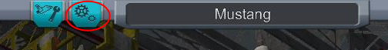

Tweakables and Action Group editor popups

Many parts have tweakable values. Right click the part while in the SPH or VAB (or in flight), to get a list of values that can be changed and saved to the craft. This can be things like wheel and engine reverse, steering setup, bomb bay doors starting open, control surface axis response etc.

Some parts with very complex setups have an extra popup menu that can be toggled from the right click menu, or by clicking on it while in the Action Group Editor, see the VTOL engine section for an example screenshot.

Helicopter balance
You can see the lift, weight and thrust balance of your craft by pressing the buttons at the bottom left of the hangar window. For helicopters, you should always have the thrust arrow pointing through the center of the weight ball in order not to pitch forwards or back automatically.
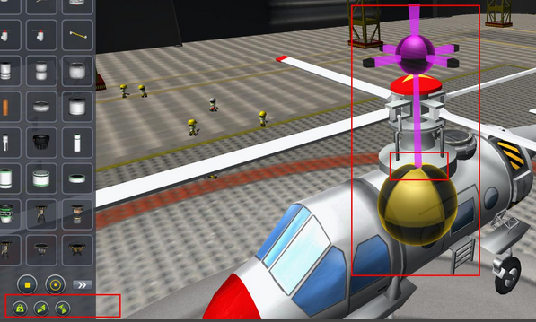

Editing config files
Part folders are found in KSP/Parts in 0.19. This may change in later versions

Each part has a file called part.cfg, which sets various properties for the part. On the most basic level you can alter things like the name of the part, mass and scale.
You can also edit engine thrust values and wing lift by experimenting a bit.

Each part can have multiple modules attached to it. These are special functions handled by plugins, and may have a set of variables you can edit to alter how the parts special functions work.

Creating an alternate part

To create a part that is based on an existing part, but with different values, create a copy of the part folder and rename it.
Open the part.cfg in the new folder, and for instance edit the line
name = FSairBrake
to
name = FSmyBetterAirBrake

In KSP 0.20.0 and later, you can just make a new cfg file with any name in the original part folder and edit that, to reuse the assets.

Scaling the part

The scale of a part is set by the rescaleFactor. Don’t use the Scale variable, it will just change the position of you attach nodes.

The default rescalefactor is 1.25, so to double the size of a part, you would add or edit the line to be
rescaleFactor = 2.5

Editing modules

A module is any text section that start with the word MODULE {
In the case of the airbrake, we could nerf it a bit, and give it a lot more steps by editing the lines from:
MODULE
{
name = FSairBrake
deployedDrag = 40
deployedAngle = 45
stepAngle = 10
}
to:
MODULE
{
name = FSairBrake
deployedDrag = 30
deployedAngle = 45
stepAngle = 2.5
}

*this module is named airBrake in v4.0 (for KSP 0.19.0)

Adding FS modules to stock parts

Some firespitter modules can be added to stock parts, like the ability to control aileron control range. Just take a look at a FS part that uses them and try copying that code. These ones should work well:

FSengineHandCrank allows EVA activation of engines
FSexternalLandingGearControl allows EVA retract/extend of landing gears and brakes
FSinfoPopup displays craft info. Would go well on a cockpit
FSradarAltitude displays radar altitude on its context menu.
FSswitchEngineThrustTransform reverse engine direction. Use on non gimballed engines.
FSwingletRangeAdjustment* adjust the control range of wing control surfaces.
*this module is named wingletRangeAdjustment in v4.0 (for KSP 0.19.0)

Parts

Wings
Found in the Aerodynamic tab

The wings work just like the stock wings, with the exception of the ability to control the range of motion of the control surfaces.
Bind action groups, or right click the part to increase the degree of motion by steps of 5 degrees, or lock the control surface at 0 degrees.
These values are editable in the cfg files.
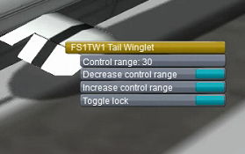

When taking off in a heavy plane, or one with insufficient lift, it can help to increase the max angle of the ailerons during takeoff. Increase the angle from the default 15 degrees to something like 25 degrees, and you might take off at a lower speed.
Adjusting the max angle of the tail wings will allow you to get more pitch control for tighter manoeuvres, or less, for a more steady craft.

This module can be applied to stock wings by adding these lines to their cfg files:
MODULE
{
name = FSwingletRangeAdjustment
stepAngle = 5
maxRange = 60
}

Wings with special lift code (biplane/F-86)

Each wing has three control axis, and the flap axis. The sliders in the tweakable menu set their response to the Pitch, Roll and Yaw, taking input from the keyboard/joystick.
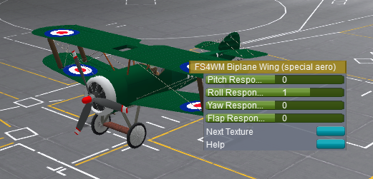

Testing
While in the Action Group editor you can test the control surface movement by pressing the W/A, Q/E, A/D and F keys.

Axis response
A setting of 1 in an axis will give the default control surface response. a 0 will give no response on that axis, and -1 will give the normal amount, but in the opposite direction.
Each part has a default control response. Wings respond top roll only, rudders to yaw, and elevators to pitch. You can override these if you want to use an elevator as a rudder for instance.

Tweaks
You can set up a bit or pitch on the main wings, or roll response on the rudder by setting a low number to an axis that is 0 by default.
Some special settings are easier to do in flight mode because of SPH tweakable symmetry constraints.

Flaps
The flap axis responds to Action Group inputs set up in the Action Group editor. Some wings also have a separate flap surface controlled by the action group. This can not be tested in the editor.

Leading Edge Slats
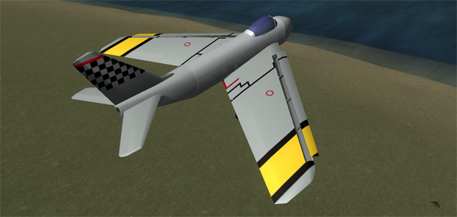
Some wings, like the F-86 fighter jet wings, may have “leading edge slats”. These are areas of the wing that deploy to create more lift, and more drag, to allow for easier takeoffs and landings by reducing the speed needed to take off or safely land.
On the F-86 wings these deploy automatically based on speed and angle of attack. Other wings using the Firespitter module may have an action group to deploy them.

Landing Gears
Found in the Utility tab

Placement
To attach landing gears to wings, it’s easiest to turn off angle snap in the bottom left corner. Press the WASDQE keys to rotate the gears so the are the right way. Due to symmetry constraints, some gears will always spawn in an odd direction.

For attaching landing gears to the main fuselage, angle snap should usually be on, to ensure a straight takeoff.

The swiveling apache gears are very special. They use custom code to rotate them left or right after launch. This means they will look weird in the hangar, and have a very limited use. Proper placement in the hangar looks like this:
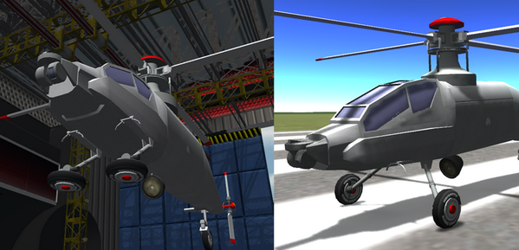

Right click events / actions

You can turn steering on and off on the landing gears by pressing the Toggle Steering button.

Steering and motor power responds to the Wheel control axis set in the game settings.

“Reverse input” is essential to turn on if you want to use the tail gear to steer.

You can increase or decrease the steering input in steps of one degree. Be careful with this, as it is easy to tip over at speed. Don’t use steering during takeoff.

The brakes can be turned on or off from EVA (and when controlling the craft), so you can stop the craft if it’s rolling away from you when on EVA. You merely need to run to catch up, and then manage to right click the landing gear.

The wheels have motor power that can be turned on for easier taxiing or for rovers. Click Enable Motor, and get rolling by pressing W or S. If you placed the gears backwards, you might want to Toggle Reverse Motor to invert these controls

The brakes can be turned on or off even while in IVA, in case the plane is rolling away from you. You can also retract/extend the gear while in IVA, so you can for instance lower the plane enough to get on a wing to enter the cockpit.

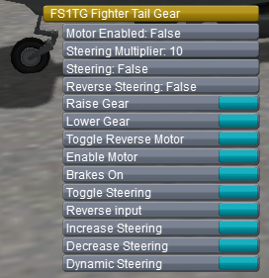

Propellers
Found in the Propulsion tab

Pushing or pulling propellers
The propellers will pull your craft by default, unlike jet engines. This can be toggled via right click or action group, so you can run the engine in reverse for easier taxiing or landing.

You can also set the start state for the propeller inverse setting in the hangar, so your craft while always have the right set up on launch. In the Action Groups editor screen, click an engine, and a small popup window will appear to let you set the start state.

Fuel
Regular propeller engine require liquid fuel and intake air. The larger engines have their own air intake, so you shouldn’t need to use an external intake.
The smaller 0.5m nose engines have no internal intake, and need an external air intake, but not as much as a jet engine, since they have lower thrust.

The electric engines use two resources, electricity, and a custom resource called FScoolant.
FScoolant is just air in disguise, and it’s just there for coding reasons. The engine supplies it automatically, so you can just forget it’s there.

A light plane with a good amount of small solar panels can run indefinitely in direct sunlight. A heavier one, or one not loaded with lots of fixed panels will need to land every so often to recharge. Decide what you think is more fun.
People have varying reactions to the fun/realism in the set ISP. To alter this, find the lines:
atmosphereCurve
{
key = 0 3500
key = 1 3500
}
And increase the values to for instance 9000 to end all your fuel troubles. I only made them to fit my idea of fun, not realistic capabilities.

Helicopter main rotors
Found in the Propulsion tab

Are you crashing? Remember to check the section helicopter balance if you haven’t already.

Placement

The helicopter rotors must be placed with the big arrow on top pointed towards the front of the craft in order to steer correctly.
As mentioned earlier, place the main rotor above you center of mass to get correct pitch.

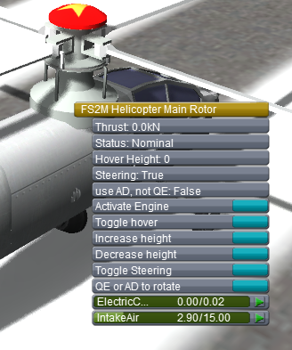

Right click events / actions

“Toggle Hover” will check your current altitude, and attempt to keep you helicopter at that altitude. It does this by constantly altering the thrust of the engine, so you might want to gun the throttle in order to give it as much authority as possible. Especially for wild maneuvers just above the ground. If you tilt too much, you will of course not have the necessary thrust in the skywards direction to maintain altitude, but you can do some pretty crazy stuff.
Also, it’s excellent for picking up heavy stuff with KAS cranes.

Speaking of picking stuff up, all propellers have three actions to set the max thrust of the engine, called Hover throttle (50%), Normal throttle (100%), and Cargo throttle (150%).
These must be set in the action group editor in the hangar, and are not available in the right click menu, due to limited screen space.

By default the helicopter rotors pitch forwards with W, and back with S.
You tilt left and right with Q and E.
You Yaw by using a tail rotor and the keys A and D
For craft based around vertical cockpits, like the rocket command pods, use the “QE or AD to rotate” to switch this, so the A and D buttons roll instead.
If so, do the same on the tail rotor, as described below.

There is also an older “Hover” function, or Emergency stabiliser, on the propellers (as you can see I’ve tried many different hovery things). By holding F (rebindable in the cfg), the propeller will try to tilt the craft in such a way that you will be pointing straight up. This works well as a panic button, or when trying to to a tricky landing in an unstable helicopter.
Be warned that this will overheat the engine and make it explode if done at full throttle for more than a few seconds!

The electric helicopter propeller

The electric propeller start out in a retracted state in order to fit on a rocket. To start it, first right click it and choose deploy.
Once fully deployed, you can either stage with spacebar, or failing that, right click it and choose “Activate” to start the engine.

Tail rotors
Found in the Control tab

The tail rotors thrust left and right to provide Yaw power. This means they need to be placed the right way to get the expected result. Usually you will need to place them with the small arrow pointing down. You can also reverse the thrust after launch if you forgot, by right clicking on it and choosing “Invert Left/Right”.

Use A and D to steer/yaw you helicopter left and right. If you are using a vertical pod as the core of your helicopter, you can switch this to use the Q and E buttons instead, by clicking “QE or AD to rotate”

If you have a heavy or very light craft and want additional Yaw control, click Increase/Reduce thrust to set the thrust from 0.25 to 32 thrust (defaults to 1)

VTOL
Found in the Propulsion tab

The Vertical Takeoff and Landing engines are propeller engines that can rotate on a pivot to provide power forwards, upwards, or some other angle, in order to act as a helicopter or plane depending on the situation. Typically you would start out with a vertical engine to do a direct vertical takeoff, and the do a controlled transition to a horizontal engine state for flying in plane mode.

Placement
The engines default to the horizontal (plane) state, so place them like you were building a plane:
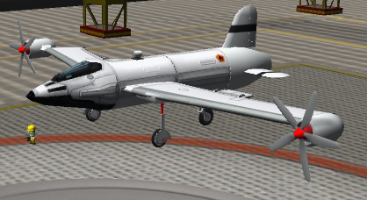

Right click events / actions

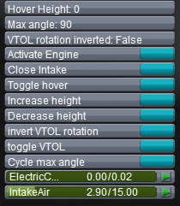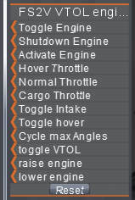

The VTOL engine shares many of the same actions as the helicopter engine, like throttle modes and hover mode. In addition, it has actions and events to control the rotation of the engine body.

Use the “toggle VTOL” engine to raise or lower the engine between the horizontal state (0 degrees) and the vertical state (90 degrees by default).

In some cases you might want an engine that can go beyond the 90 degrees vertical rotation, in order to slow you craft down for instance. use the “Cycle max angle” action/event to use either 45, 90 or 130 degrees as the fully deployed state. You can define up to six max angles to cycle between in the part.cfg file.

To get full control, you will need to assign action groups to control the rotation of the engine body in smaller increments, using the “raise engine” and “lower engine” actions. The standard increments are 10 degrees. This can be changed in the cfg file.

You can also rotate the engine below 0 degrees using this incremental rotation, up to a limit set in the cfg (-90 degrees by default).

The VTOL engines check at the start of the flight which side of the craft they are one, and set an invert state on or off depending on if they are on the left or right side. If for some reason the engines rotate the opposite way of what you expect, click the “invert VTOL rotation” button. You might have to toggle the vertical state on and off before it will act normally after this if you were not at 0 degrees already.

You can also setup the angle setup and start position of the engines rotation by clicking the part in Action Editor Mode. Any rotation selected in the hangar will become the start rotation when you launch.
Using the Use Preset button to go vertical also allows you to see the thrust arrow in VTOL mode, which can be very useful for balancing your craft.
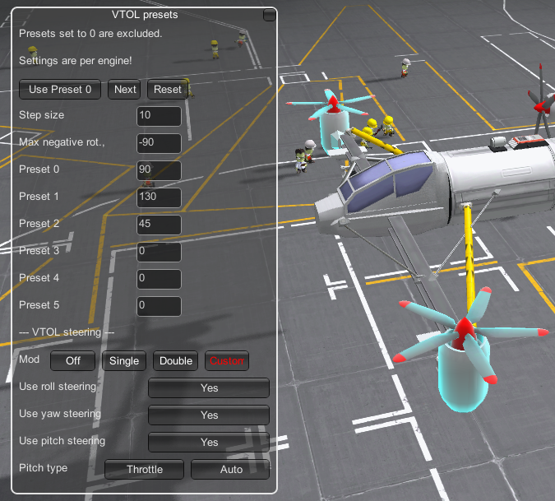

VTOL steering modes

You can build a craft with no other control surfaces than the VTOL engines by using different VTOL steering modes. This tilts the engines or varies their thrust output to induce roll, pitch or yaw.
There are Four modes:
Off - No steering
Single Pair - Use this if you have two engines in a pair. The engines rotate to create pitch and yaw, and vary thrust to create roll.
Double Pair - Use this if you have two pairs behind each other. Pitch and roll is handled by thrust variation. Yaw is still done by counteracting rotation.
Custom - A menu will pop up to allow you to turn each control mode on or off. You can also override the systems guess for each engine pairs front/rear pitch control setting.

If the pitch type is Throttle, Each engine auto detects whether it’s in front of or behind the center of mass at launch. Engines to the front increase thrust to pitch up, engines at the back decrease thrust at the same time (And vice versa). If for some reason you want to change this, use the custom menu to switch between Front/Back setting on each engine pair.

If you need to switch steering on or off during flight without losing your custom steering setup, you can assign the an action group button to do so, using the action “VTOL steering Toggle”

Cockpits
Found in the Pods tab

All the cockpits have internal views that can be activated by pressing C. Press V to switch between the seats. Some cockpits have working switches, control sticks/wheels/pedals and other nifty gadgets in them.

Apache cockpit monitors
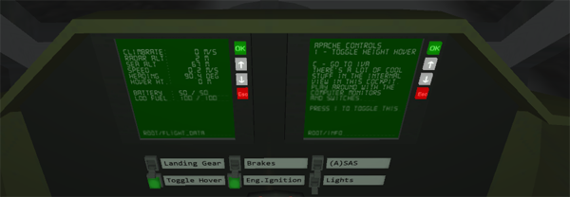

The apache cockpit has four working Multifunction Displays. By default they will display flight data, craft popup text (if available), and main menu on the respective screens.

You can click the OK, up, down, and Esc buttons to navigate the menus and change what is displayed.
You can show flight data in metric or imperial/aviation units, and toggle between surface/orbit/target speed in the Settings menu.
Use the Fuel menu to show all available fuels in the craft. The main flight data screen will only show liquid fuel and battery power.
You can also toggle gears, brakes, hover mode, lights and ASAS, as well as activate the Abort actions from these monitors.

Or if you prefer, use the old fashioned switches that are below the monitors. These are also found in other cockpits.

Texture switching and customizable nose art

Some part sets, like the biplane parts and oblong fuselage sections have alternate textures in a single part. A racing green english plane can be built with the same parts as the Red Baron’s obviously red plane. Just right click the part and choose next texture to browse through the alternatives.

The Bomber cockpit has a piece of default nose art on it. This can be swapped for alternate pieces found in the “FS_bomberCockpit\nose art” folder. You can create you own by following the noseArtUV.png UV map guide.

To add textures to a part, list them in the part’s cfg file using the FStextureSwitch module, documented here.

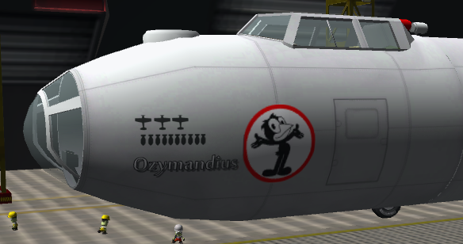

Air brakes
Found in the Control tab

The air brakes are small metal plates that can rotate up and create drag when activated. Use the right click menu to “toggle Air Brake”, or set up action groups to “raise air brake” and “lower air brake” for incremental control. They will create 50 drag per air brake at full deployment, or 10 drag per increment.
These values are also configurable in the cfg file.

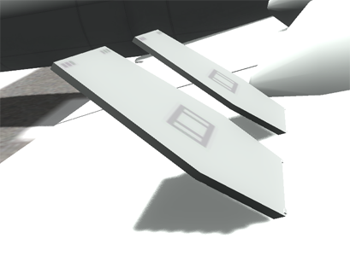

Seaplane floats
Found in the structural tab

The seaplane floats are an ideal way to get around a planet covered in mostly water. The endless splashy ocean is a much more forgiving landing strip than the bumpy land.

Placement

Start by attaching the Seaplane float Strut to a wing or other suitable surface. Place other sections as appropriate, possibly including the landing gear bay sections if you want to be able to take off from the runway at speed.
The tail float section is special, because it includes a small rudder. This rudder will only work when in contact with water, and so will not interfere with your yaw controls when flying.

It’s a good idea to place the floats at an angle as seen in the picture below, so that the plane will have a high degree of incidence (built in wing angle of attack) when taking off from the water.
It’s much harder to get the necessary lift to take off when you are in the water, and a small change in weight balance due to fuel consumption can leave you stranded, unable to take off if you don’t have a high built in angle.

The landing gear bays can steer and retract just like the other landing gears.

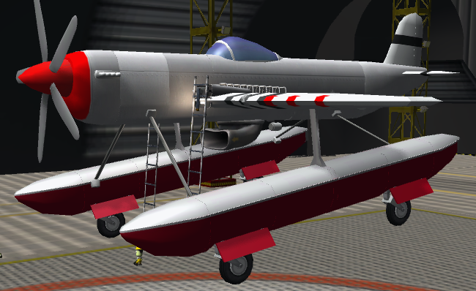

Gyroscope (Avionics) / ASAS
Found in the control tab

The Gyroscope part is exactly the same as the stock Avionics nose cone, except surface attachable.

The Apache’s Nose ASAS unit is exactly the same as the stock ASAS part, except smaller, and meant to be placed on the nose of a craft, or surface attached somewhere else.

Craft Info Popup
Found in the Science tab

The info popup part allows you to store text info about the craft. You can write anything you like, but a good idea is to write down what the different action groups do, either so you can remember a complex setup while flying, or if you want to share the craft with other people, and you need to send along instructions.

You can display the info box by pressing i (both in flight and in the hangar), or by clicking on it in the hangar’s action group editor, or by using the right click menu on it while flying.

Click the edit button to edit the lines of text. The lines are saved in the craft file if you do it in the hangar, or in the saved game persistence (i.e., not in the craft file), if you edit while flying.

When you launch the craft, the info popup will be displayed automatically for 20 seconds, unless you deactivate this function by pressing the [Y/N] Show on Start button.

Information in the popup will also be displayed in one of the apache monitors if available.

If you are using RCS thrusters, and find that pressing i to go up toggles this window on and off annoyingly, use the button [Y/N] Use hotkey to disable the hotkey functionality. Or rebind the hotkey in the part.cfg

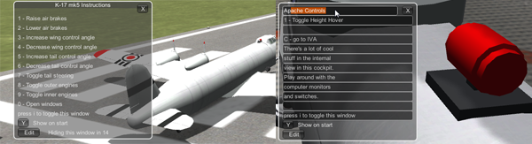

Bomb Bay
Found in the Structural tab

The empty bomb bay can be loaded with anything, preferably with something that can be detached, either via decouplers, or docking ports.
It can be tricky placing stuff in the bay, so you will probably have to do it before the whole craft is assembled.
There are some attach points in the roof of the bay. Given some patience you can for instance attach a docking port to these.

Of course, if the Bomb Bay doors are closed, it will be pretty tricky to put stuff in them. That’s why you can open them while in the hangar. Go to the Action Group Editor screen, then click the Bomb Bay. A small window will pop up that lets you open and close the doors, and set the start state of the doors for launch.

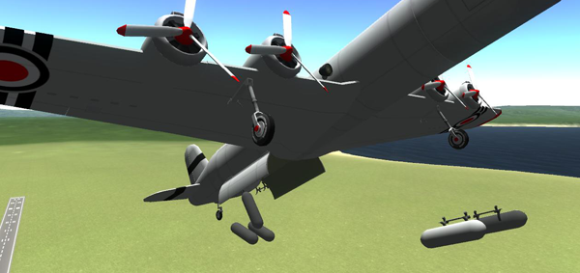

Trim adjustment tool
Found in the Control tab

Attach the small Trim adjustment tool to your craft to quickly change trim settings to a preset, or do small controlled adjustments. Trimming normally with alt + arrow keys can be dangerous at launch, but pressing a button is so easy, even your mother could do it!

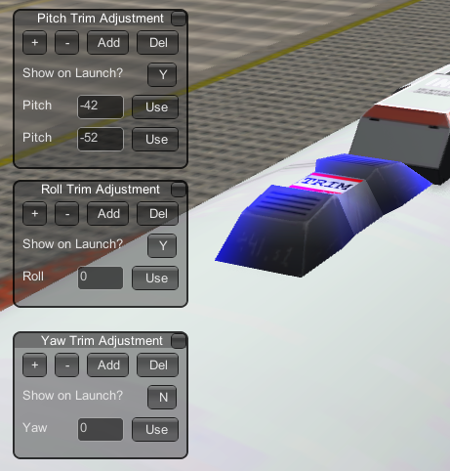

Clicking on the Trim tool in the action editor brings up three separate windows, pitch, roll, and yaw.
You can add up to three trim presets that will be saved to the vessel, or any number of presets during flight.

Buttons
[ + ] Adds one step to the active trim on the craft. (Up for pitch, Right for roll/Yaw)
[ - ] Subtracts one step to the active trim on the craft. (Down for pitch, Left for roll/Yaw)
[Add] Adds one preset line
[Del] Removes one preset line (You can have no presets if you wish, but one is always added on Load)
Show on Launch [Y/N] Toggles whether this popup box will appear when the craft is launched/loaded

Presets

Each line has an editable text field, and a button to use the trim value written in that field.
Values are in percent of total trim, so -23.5 will give 23.5% of total possible steering input.
Be careful to click outside the text field after you’ve edited it, as it will keep taking inputs instead of letting you steer if you don’t.

Tips

If you find a good pitch trim setting for takeoff, add the action “Use Pitch Preset 1” to the Stage Action Group, to apply that trim value as soon as you start your engines.

If you don’t use the Abort Action Group for anything else, you can add the actions for toggling the popup windows to that. Then you can just press Backspace to show or hide all or some of the windows.

The roll is usually way overpowered in planes when using the keyboard. Add the Action “”Roll trim +1 step” to for example action group 8, and -1 roll to 9, to make very gentle turns by pressing these buttons a few times.

Water Launch System
Found in the Control tab

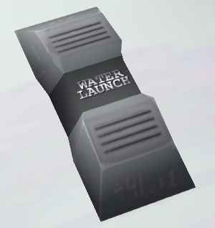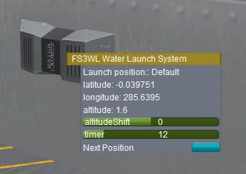

By adding the water launch system to your craft, you can choose to automatically be moved to the water near the Space Center when you launch, or another previosuly saved location on Kerbin. It will take a few seconds for the craft to drop down and settle in the water.

To choose the launch location, right click the part and browse through the saved locations using the Next Position button. The default location launches you on the runway or launch pad.

If you find that you launch too high or too low, adjust the altitude shift slider to add or subtract height from the saved launch point.

You can save new locations while you are on a flight. Right click the Water Launch part and click Save Position. Fill in a name for the location, save it, and it will be stored in a file in GameData\Firespitter\PluginData. It will now be available for use in the hangar.

Please note that you have to be moving no faster than 0.2 m/s in order to quick save your game while in the water.

On slower machines, it’s possible you will be moved back to the runway at the last moment. This might be solved by changing the amount of time the Water Launch system tries to move you.
In the hangar, right click the part and adjust the timer slider. The slider value represents the time spent trying to move your craft. A fast machine can use 5 seconds or so. A slower machine might need a lot of time.

